Weekly Construction Progress Report – Week 33
Harrow Bay Offshore Wind · 10 Aug – 16 Aug 2026
Elena Márquez · 17 August 2026 · HB-PM-RPT-2026-W33

1. Summary
No monopile was installed this week; the total remains 11 of 40. The foundation campaign is 3 piles behind the Rev 2 baseline (14 planned). Waiting on weather amounted to 46 hours – well above the planning allowance of 25 hours per week.
Area | Status | Comment
Overall schedule | Red | 11/40 monopiles vs. 14 planned
Foundations | Red | TPs installed: 11
Offshore substation | Green | Jacket installed 27 Jun
Cables | Red | Export cable 2 delay – HB-RISK-017
HSE | Amber | Near miss reported

2. Progress
Metric | This week | Cumulative | Plan (cum.) | Variance
Monopiles installed | 0 | 11 | 14 | -3
Transition pieces installed | 1 | 11 | – | –
Waiting on weather (h) | 46 | 285 | – | –
Persons on board (avg.) | 104 | – | – | –
Man-hours MV Sea Atlas | 8,657 | 153,021 | – | –
Lost time injuries | 0 | 0 | 0 | 0
Recordable injuries | 0 | 1 | – | –
Near misses reported | 1 | 4 | – | –
HSE observation cards | 15 | – | – | –

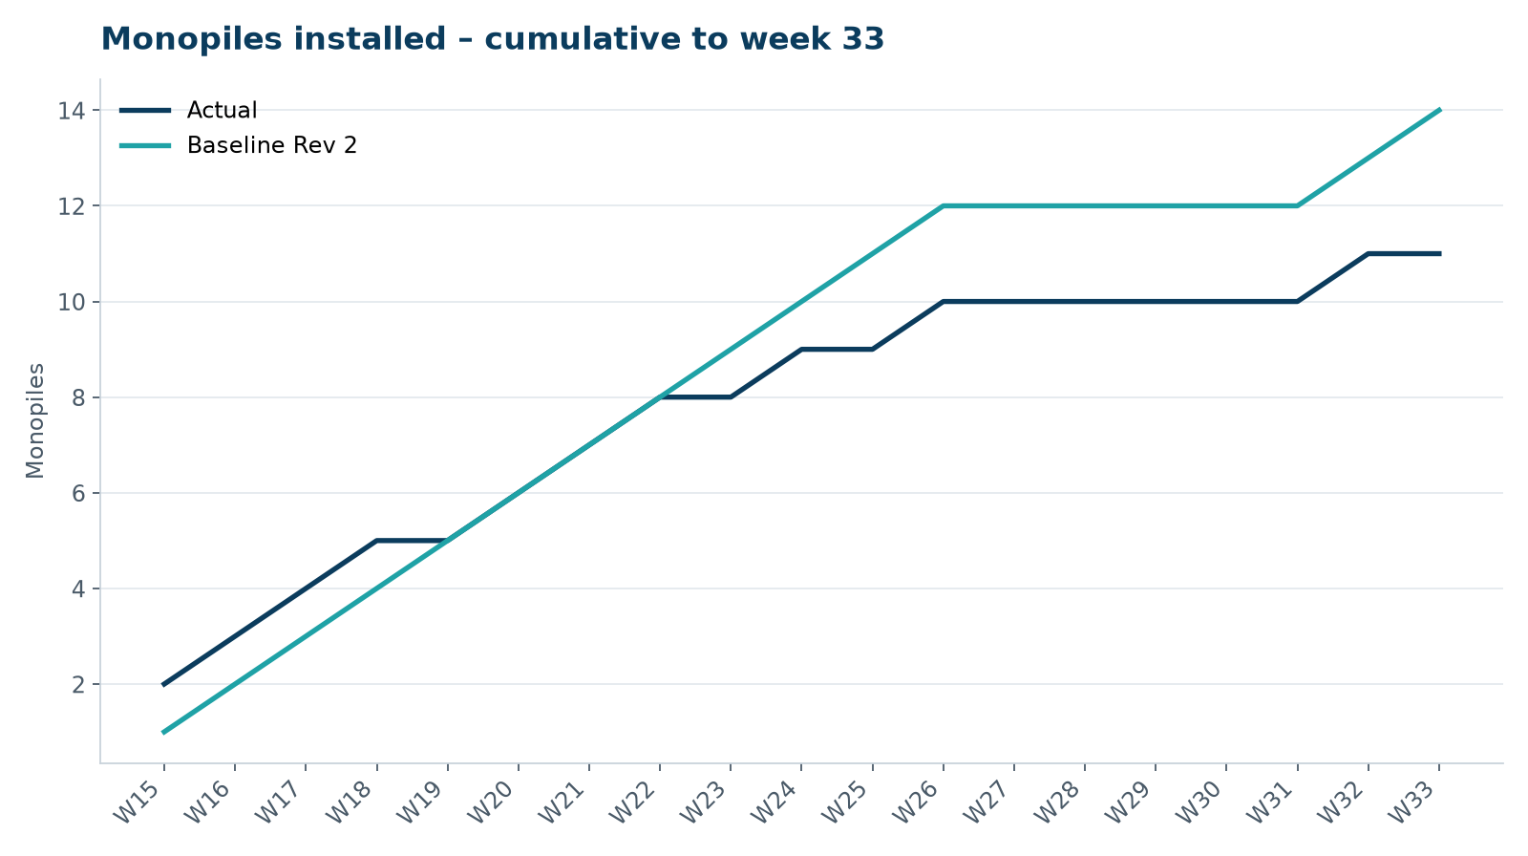
Figure 1 – Monopile installation progress, W15 to W33

3. Key activities this week
- 46 hours waiting on weather; transition piece HB-A11 installed on 11 August.
- Severn Subsea Cables submitted its recovery programme on 14 August: revised delivery of export cable 2 on 12 March 2027 (was 15 January 2027).
- Preparation for the offshore substation topside lift; 2 km exclusion zone agreed with the marine coordination centre.

4. Health and safety
No lost time injuries. One near miss reported (minor; closed out on board). 15 observation cards submitted; top theme: housekeeping on the main deck.

5. Environment
- No piling this week; passive acoustic monitoring stations HB-PAM-01 to -04 operational.

6. Issues and risks
- HB-RISK-017 export cable 2 delay – recovery programme received; resequencing of cable lay campaign in progress.
- HB-RISK-001 weather: 46 h downtime this week.

7. Look-ahead next week
OSS topside lift (weather window 18–20 August).
Prepared by Project Controls (Gareth Lewis); approved by Elena Márquez. Distribution: project team, Steering Committee, Halden Turbine Systems, Lenders' Technical Adviser.

